29. Keeping It Flowing: An Interview with a Veteran Plumber

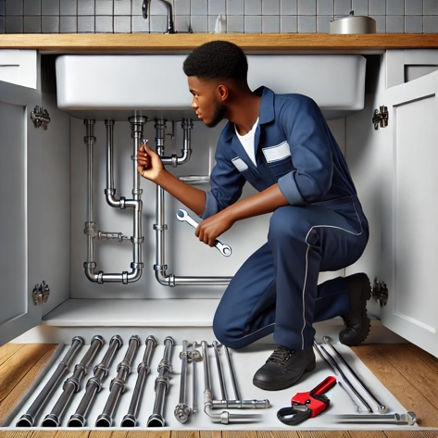

Q: What inspired you to get into plumbing?
A: Honestly, it was a combination of practicality and curiosity. Growing up, I liked fixing things around the house. I remember my dad saying, "If you know how to fix a pipe, you'll never be out of work." He was right. Plumbing is one of those trades that's always in demand—people always need water, and pipes always need fixing.

Q: What does a typical day look like for a plumber?
A: Every day is different, and that's one of the things I love about it. Some days, I’m installing new fixtures in a home or business—sinks, toilets, water heaters. Other days, I’m troubleshooting problems, like a leaking pipe or a clogged drain. And then there are emergencies, like when a pipe bursts, and you're working late into the night to help someone out. It’s physical work, but there’s a lot of problem-solving involved too.

Q: What skills do you think are most important for someone entering the trade?
A: You’ve got to be good with your hands, of course, but it’s more than that. You need attention to detail—miss one tiny step, and it could lead to a big problem later. Communication is huge, too. You’re not just fixing pipes; you’re talking to customers, explaining what’s wrong, and helping them make decisions. Dependability is key—people need to trust that you’ll show up and do the job right.

Q: Are there challenges you face in this career?
A: Definitely. The physical side can be tough, especially when you’re working in tight spaces or lifting heavy equipment. It’s also a trade where you’re dealing with unexpected problems—like discovering a corroded pipe in the middle of a job—and you’ve got to think on your feet. And then there’s the weather. Ever had to fix a busted pipe outside in the middle of winter? It’s not fun, but it’s part of the job.

Q: What advice would you give to someone starting out in plumbing?
A: Get the basics down first. Learn how to read blueprints and understand building codes because they’ll guide almost everything you do. Don’t skip out on safety training—OSHA certifications are a must. And find a mentor. I can’t stress that enough. Working alongside someone experienced will teach you things you’ll never get from a book.

Q: How do you see the future of plumbing? Are there new trends or technologies?
A: Absolutely. Technology is changing the game. Smart plumbing systems are becoming more common—things like sensors that detect leaks or adjust water pressure automatically. Green plumbing is another big one. People want water-saving systems like low-flow fixtures and tankless water heaters. If you keep learning and adapt to these trends, you’ll have no trouble staying relevant in the field.

Q: Any final thoughts for someone considering plumbing as a career?
A: Just go for it. It’s a trade where you can make a good living, work with your hands, and feel like you’re making a difference. It’s not always glamorous, but it’s honest, steady work. If you’re dependable, curious, and willing to learn, you’ll go far.

Keeping It Flowing: An Interview with a Veteran Plumber
Multiple Choice Questions

1. What does the plumber mean by, "If you know how to fix a pipe, you'll never be out of work"?
A) Plumbing is a seasonal job with limited opportunities.
B) Plumbing skills ensure job stability due to consistent demand.
C) Plumbing is the most profitable trade in construction.
D) Fixing pipes is the only important task in plumbing.

2. Based on the article, what can you infer about the relationship between plumbing and problem-solving?
A) Plumbing rarely involves complex issues.
B) Plumbing issues are solved through knowledge of regulations.
C) Problem-solving is only necessary for advanced plumbing jobs.
D) Plumbing requires on-the-spot problem-solving skills for unexpected challenges.

3. Why might the physical demands of plumbing appeal to some individuals, despite the challenges?
A) It allows plumbers to avoid desk jobs.
B) The physical work eliminates the need for technical skills.
C) Physical labor leads to faster promotions in the field.
D) Working conditions are usually ideal.

4. How does the article illustrate the importance of communication skills in plumbing?
A) By describing how plumbers must coordinate with suppliers.
B) By emphasizing the need to explain issues and solutions to customers.
C) By highlighting the role of communication in applying for certifications.
D) By showing how plumbers resolve disagreements with other tradespeople.

5. What inspired the interviewee to pursue plumbing?
A) A desire to work with technology.
B) The promise of high wages in the field.
C) A family history of plumbing businesses.
D) Practicality and curiosity about fixing things.

6. What can you infer about the plumber's stance towards the future of plumbing based on his response to the question about new trends?
A) He is worried that new technology will make his job obsolete.
B) He is indifferent to the changes happening in the plumbing industry.
C) He sees the opportunities that new technology presents.
D) He believes that traditional plumbing methods are still the best.

Keeping It Flowing: An Interview with a Veteran Plumber
Multiple Choice Key

1. B
2. D
3. A
4. B
5. D
6. C

Kahoot Link: https://create.kahoot.it/details/4dd86c8a-32f0-47a5-bbc3-68ad37e6c0c6

